Appendix A: Virginia Clean Energy Advisory Board Bylaws

VIRGINIA CLEAN ENERGY ADVISORY BOARD
BYLAWS
ARTICLE I. APPLICABILITY
Section 1. General.
The provisions of these Bylaws are applicable to all proceedings of the Virginia Clean Energy Advisory Board (the Board) to the extent that the same are not inconsistent with the Code of Virginia or Executive Orders applicable to these proceedings. Whenever the provisions of these Bylaws are in conflict with the provisions of the Code of Virginia or an applicable Executive Order, the latter shall control.
Section 2. Board and Limitations.
The Board is constituted under § 45.2-1913 of the Code of Virginia as an advisory board in the executive branch of the Commonwealth of Virginia. The Board is specifically charged with the duties and responsibilities set forth in Title 45.1, Chapter 27, of the Code of Virginia, primarily for the purpose of establishing, with the approval of the Director of the Department of Energy, a pilot program for disbursing loans or rebates for the installation of solar energy infrastructure in low-income and moderate-income households.

ARTICLE II. MEMBERS AND STAFF
Section 1. Appointment of Members; Terms; Vacancies.
All appointments shall be in accordance with § 45.2-1914 of the Code of Virginia. Any ex officio members of the Board shall serve a term coincident with his or her term of office. Nonlegislative citizen members of the Board shall be appointed for a term of three years. Appointments to fill vacancies, other than by expiration of a term, shall be for the unexpired terms. Any appointment to fill a vacancy shall be made in the same manner as the original appointment. All members may be reappointed.
Section 2. Election of Chair and Vice-Chair.
The Board shall elect from its membership a Chair and Vice-Chair, both of whom shall serve in such capacities at the pleasure of the Board, for terms commencing at the Annual Meeting on which they were elected and ending at the next Annual Meeting.
Vacancies in the position of Chair or Vice-Chair shall be filled for the remainder of the term by voice vote or roll call vote of the Board at the next meeting following the occurrence of the vacancy. Until the Board fills such vacancy for the office of Chair, the Vice-Chair shall assume the office of Chair.

Section 3. Board Requests for Staff Assistance.
Department of Energy staff shall serve as staff to the Board.
Any Board member may request assistance from staff provided the request has been coordinated through the Chair or Vice-Chair of the Board.

ARTICLE III. MEETINGS
Section 1. Regular Meetings.
Meetings of the Board shall be held at the call of the Chair or whenever a majority of the members so request, at such time and place as the Board may determine. No business requiring a vote or final decision of the Board may be conducted in the absence of a quorum, as defined below.
Section 2. Annual Meetings.
The first regular meeting of the calendar year shall be designated as an annual meeting. Elections of officers shall be held at the Annual Meeting.
Section 3. Committee Meetings.
The Board may establish standing committees consisting of at least five members of the Board from time to time as needed to carry out the work of the Board.
Section 4. Compliance with FOIA.
All meetings of the Board or a Committee of the Board shall be noticed and conducted in conformance with the Virginia Freedom of Information Act (Va. Code § 2.2-3700 et seq.).
Section 5. Quorum.
For any meeting of the Board, a majority of the members of the Board shall constitute a quorum. If a quorum has not been achieved, the meeting of the Board may proceed; provided, however, that voting on matters before the Board shall be postponed until a meeting of the Board at which a quorum is present.
Section 6. Conduct of Meetings.
The Chair of the Board shall conduct the meetings of the Board and shall rule on the interpretation and application of the Virginia Code and these by-laws.
The Vice-Chair of the Board shall preside over meetings of the Board in the absence of the Chair. In the event that neither the Chair nor the Vice-Chair of the Board shall be in attendance at a meeting where a quorum is nonetheless present, any member of the Board may call the meeting to order, and the members present shall elect a Chair pro tempore to preside over the meeting. Where a quorum is not present, a vote of the majority of those members present shall determine the Chair pro tempore.
All actions and decisions of the Board shall be made upon the motion of a member, and approved by a majority of the members who are present and voting.

The Chair shall put the question submitted to the Board for a voice vote and shall call for a vote only after determining that there are no more Board members who wish to speak or upon approval of a motion to close debate.
Any member who may not participate in the Board’s consideration of a matter under the State and Local Government Conflict of Interests Act, § 2.2-3100 et seq. of the Code of Virginia, must comply with the disclosure requirements of the Act and not participate in the discussion or vote on the matter.
If it appears to the Chair, upon the voice vote being taken, that the members of the Board are divided on any question, the Chair shall determine the vote of the members by roll call. A tie vote on any matter defeats the motion or issue upon which the vote is taken. At the conclusion of the vote on the motion, the Chair shall announce whether the motion has been adopted or defeated.
Section 7. Agenda.
The proposed agenda for any meeting shall be determined by the Chair in consultation with staff. In addition, any members of the Board may suggest items to be included on the agenda.
The agenda for regular meetings of the Board will normally include the following: (1) review and approval of the last minutes of the Board; (2) a status report on the work plan and action items agreed to by the Board; and (3) other information of interest to the Board.
An opportunity shall be provided at each meeting of the Board for public comment. Any person who desires to speak will be asked to provide his or her name and the matter to be addressed prior to each meeting at which the public is able to comment.
Section 8. Amendments.
The bylaws of the Board may be amended at any regular meeting of the Board at which a quorum is present by a majority vote.
Section 9. Rules of Order.
Informal rules of order shall govern all matters of procedure unless objected to by any Board member. If such an objection occurs, then “Robert’s Rules of Order, Newly Revised” shall be the parliamentary authority for all matters of procedure not specifically covered by these bylaws.

ARTICLE IV. REMOTE PARTICIPATION OF INDIVIDUAL MEMBERS.
Section 1. Authority and Scope
A. The policies in this Article are adopted pursuant to the authorization of Va. Code § 2.2-3708.3 and are to be strictly construed in conformance with the Virginia Freedom of Information Act (VFOIA), Va. Code §§ 2.2-3700—3715. This policy supersedes the Board’s prior policy on remote participation in Board meetings (“Policy on Individual Participation in Clean Energy Advisory Board Meetings by Electronic Means under § 2.2-3708.2,” adopted February 12, 2020).

B. In addition to the Board itself, this policy also applies to the remote participation of members in all committees and subcommittees of the Board. When this Article is applied to a committee or subcommittee, the term “Board” shall be deemed to refer to the committee or the subcommittee, and terms “Chairman” and “Vice Chairman” shall refer to the Chairman and Vice Chairman of the committee or subcommittee.
C. This policy shall not govern an electronic meeting conducted to address a state of emergency. Any meeting conducted by electronic communication means under such circumstances shall be governed by the provisions of Va. Code § 2.2-3708.2. All-virtual public meetings (as opposed to meetings in which an individual member participates remotely) are covered under Article V.
Section 2. Definitions
The terms “Board,” “Chair,” and “Vice Chair” have the meanings attributed to them in Section 1, Subsection B, when this Article is applied to a committee or subcommittee of the Board.
“Remote participation” means participation by an individual member of the Board by electronic communication means in a public meeting where a quorum of the Board is physically assembled, as defined by Va. Code § 2.2-3701.
“Meeting” means a meeting as defined by Va. Code § 2.2-3701.
“Notify” or “notifies,” for purposes of this policy, means written notice, such as email or letter. Notice does not include text messages or communications via social media.
Section 3. Mandatory Requirements
Regardless of the reasons why the member is participating in a meeting from a remote location by electronic communication means, the following conditions must be met for the member to participate remotely:
(a) A quorum of the Board must be physically assembled at the primary or central meeting location; and
(b) Arrangements have been made for the voice of the remotely participating member to be heard by all persons at the primary or central meeting location. If at any point during the meeting the voice of the remotely participating member is no longer able to be heard by all persons at the meeting location, the remotely participating member shall no longer be permitted to participate remotely.
Section 4. Process to Request Remote Participation
A. On or before the day of the meeting, and at any point before the meeting begins, the requesting member must notify the Chair (or the Vice-Chair if the requesting member is the Chair) that the member is unable to physically attend a meeting due to (i) a temporary or permanent disability or other medical condition that prevents the member’s physical attendance, (ii) a family member’s medical condition that requires the member to provide care for such family member, thereby preventing the member’s physical attendance, (iii) the member’s principal residence location being more than 60 miles from the meeting location, or (iv) a personal matter, the nature of which is identified with specificity by the member.

B. The requesting member shall also notify the Board’s staff liaison of their request, but their failure to do so shall not affect their ability to remotely participate.
C. If the requesting member is unable to physically attend the meeting due to a personal matter, the requesting member must state with specificity the nature of the personal matter. Remote participation due to a personal matter is limited each calendar year to two meetings or 25 percent of the meetings held per calendar year rounded up to the next whole number, whichever is greater. There is no limit to the number of times that a member may participate remotely for the other authorized purposes listed in (i)—(iii) above.
D. The requesting member is not obligated to provide independent verification regarding the reason for their nonattendance, including the temporary or permanent disability or other medical condition or the family member’s medical condition that prevents their physical attendance at the meeting.
E. The Chair (or the Vice-Chair if the requesting member is the Chair) shall promptly notify the requesting member whether the member’s request is in conformance with this policy, and therefore approved or disapproved.
Section 5. Process to confirm approval or disapproval of participation from a remote location.
When a quorum of the Board has assembled for the meeting, the Board shall vote to determine whether: (a) the Chair’s decision to approve or disapprove the requesting member’s request to participate from a remote location was in conformance with this policy; and (b) the voice of the remotely participating member can be heard by all persons at the primary or central meeting location.
Section 6. Recording in Minutes
A. If the member is allowed to participate remotely due to a temporary or permanent disability or other medical condition, a family member’s medical condition that requires the member to provide care to the family member, or because their principal residence is located more than 60 miles from the meeting location the Board shall record in its minutes (1) the Board’s approval of the member’s remote participation; and (2) a general description of the remote location from which the member participated.
B. If the member is allowed to participate remotely due to a personal matter, such matter shall be cited in the minutes with specificity, as well as how many times the member has attended remotely due to a personal matter, and a general description of the remote location from which the member participated.
C. If a member’s request to participate remotely is disapproved, the disapproval, including the grounds upon which the requested participation violates this policy or the Virginia Freedom of Information Act, shall be recorded in the minutes with specificity.
Section 7. Closed Session
If the Board goes into closed session, the member participating remotely shall ensure that no third party is able to hear or otherwise observe the closed meeting.

Section 8. Strict and Uniform Application of this Policy
A. This Policy shall be applied strictly and uniformly, without exception, to the entire membership, and without regard to the identity of the member requesting remote participation or the matters that will be considered or voted on at the meeting.
B. The Chair (or the Vice-Chair, as applicable) shall maintain the member’s written request to participate remotely and the written response for a period of one year, or other such time required by records retention laws, regulations, and policies.

ARTICLE V. ALL-VIRTUAL MEETINGS
Section 1. Authority and Scope
The provisions of Article IV, Section 1 are incorporated into this Article by reference, and apply to his Article, mutatis mutandis.
Section 2. Definitions
“All-virtual public meeting” means a public meeting conducted by the Board using electronic communication means during which all members of the public body who participate do so remotely rather than being assembled in one physical location, and to which public access is provided through electronic communication means, as defined by Va. Code § 2.2-3701.
The terms “Board,” “Chair,” and “Vice Chair” have the meanings attributed to them in Article IV, Section 1, Subsection B, when this Article is applied to a committee or subcommittee of the Board.
“Meeting” means a meeting as defined by Va. Code § 2.2-3701.
“Notify” or “notifies,” for purposes of this policy, means written notice, including, but not limited to, email or letter, but does not include text messages or messages exchanged on social media.
Section 3. When an all-virtual public meeting may be authorized
An all-virtual public meeting may be held only when:
(a) It is impracticable or unsafe to assemble a quorum of the Board in a single location; or other circumstances warrant the holding of an all-virtual public meeting, including, but not limited to, the convenience of an all-virtual meeting; and
(b) The Board has not had more than two all-virtual public meetings, or more than 25 percent of its meetings rounded up to the next whole number, whichever is greater, during the calendar year; and
(c) The Board’s last meeting was not an all-virtual public meeting.
Section 4. Process to Authorize an All-Virtual Public Meeting
The Board may schedule its all-virtual public meetings at the same time and using the same procedures used by the Board to set its meetings calendar for the calendar year. Alternatively, if the Board wishes to have an all-virtual public meeting on a date not scheduled in advance on its meetings calendar, and an all-virtual public meeting is authorized under Section 3 above, the Board Chair may schedule an all-virtual public meeting provided that any such meeting comports with VFOIA notice requirements.
Section 5. All-Virtual Public Meeting Requirements
The following applies to any all-virtual public meeting of the Board that is scheduled in conformance with this Policy:
(a) The meeting notice indicates that the public meeting will be all-virtual and the Board will not change the method by which the Board chooses to meet without providing a new meeting notice that comports with VFOIA;
(b) Public access is provided by electronic communication means that allows the public to hear all participating members of the Board;
(c) Audio-visual technology, if available, is used to allow the public to see the members of the Board;
(d) A phone number, email address, or other live contact information is provided to the public to alert the Board if electronic transmission of the meeting fails for the public, and if such transmission fails, the Board takes a recess until public access is restored;
(e) A copy of the proposed agenda and all agenda packets (unless exempt) are made available to the public electronically at the same time such materials are provided to the Board;
(f) The public is afforded the opportunity to comment through electronic means, including written comments, at meetings where public comment is customarily received; and
(g) There are no more than two members of the Board together in one physical location.
Section 6. Recording in Minutes
Minutes are taken as required by VFOIA and must include the fact that the meeting was held by electronic communication means and the type of electronic communication means used.
Section 7. Closed Session
If the Board goes into closed session, transmission of the meeting will be suspended until the public body resumes to certify the closed meeting in open session.
Section 8. Strict and Uniform Application of this Policy
This Policy shall be applied strictly and uniformly, without exception, to the entire membership, and without regard to the matters that will be considered or voted on at the meeting.
Adopted by the Board on June 23, 2020; revised on November 8, 2022.

Appendix B: Clean Energy Advisory Board Statute, Code of Virginia

Code of Virginia Title 45.2. Mines, Minerals and Energy. Chapter 19. Solar Energy. Article 3, Clean Energy Advisory Board.

§ 45.2-1912. Definitions.
As used in this article, unless the context requires a different meaning:
"Board" means the Clean Energy Advisory Board created pursuant to § 45.2-1913.
"Fund" means the Low-to-Moderate Income Solar Loan and Rebate Fund created pursuant to § 45.2-1916.
"Program" means the Low-to-Moderate Income Solar Loan and Rebate Pilot Program created pursuant to § 45.2-1917.
2021, Sp. Sess. I, c. 387.

§ 45.2-1913. Clean Energy Advisory Board; purpose.

The Clean Energy Advisory Board (the Board) is established as an advisory board in the executive branch of state government. The purpose of the Board is to establish a pilot program for disbursing loans or rebates for the installation of solar energy infrastructure in low-income and moderate-income households.
2019, c. 554, § 45.1-395; 2021, Sp. Sess. I, c. 387.
§ 45.2-1914. Membership; terms; quorum; meetings.

The Board shall have a total membership of 17 members that shall consist of 16 nonlegislative citizen members and one ex officio member. Members may reside within or without the Commonwealth. Nonlegislative citizen members shall be appointed as follows:
- Six nonlegislative citizen members to be appointed by the Speaker of the House of Delegates upon consideration of the recommendations of the Board of Directors of the
Maryland-DC-Delaware-Virginia Solar Energy Industries Association (the MDV-SEIA Board) and the Governor's Advisory Council on Environmental Justice (the Council), one of whom shall be a designee of the Virginia Housing Development Authority, created pursuant to the provisions of Chapter 1.2 (§ 36-55.24 et seq.) of Title 36; one of whom shall be a rooftop solar energy professional or employer or representative of rooftop solar energy professionals; one of whom shall be a current or former member of the Council; one of whom shall be a member or representative of the Virginia, Maryland and Delaware Association of Electric Cooperatives (VMDAEC); one of whom shall be an expert with experience developing low-income or moderate-income incentive and loan programs for distributed renewable energy resources; and one of whom shall be an attorney who is licensed to practice in the Commonwealth and maintains a legal practice dedicated to rural development, rural electrification, and energy policy;
- Three nonlegislative citizen members to be appointed by the Senate Committee on Rules upon consideration of the recommendations of the MDV-SEIA Board, one of whom shall be a solar energy professional or employer or representative of solar energy professionals, one of whom shall work for or with a Virginia-based investor-owned electric utility company, and one of whom shall be a member or representative of VMDAEC; and
- Seven nonlegislative citizen members to be appointed by the Governor upon consideration of the recommendations of the MDV-SEIA Board and the Council and subject to confirmation by the General Assembly, one of whom shall be an attorney who is licensed to practice in the Commonwealth and maintains a legal practice in renewable energy law and transactions, one of whom shall be an attorney who is licensed to practice in the Commonwealth and specializes in tax law and energy transactions, one of whom shall be an attorney with the Division of Consumer Counsel created pursuant to the provisions of § 2.2-517, one of whom shall be an employee of a community development financial institution who specializes in impact investing, one of whom shall be a member of a Virginia environmental organization, and two of whom shall be designees of the Department of Housing and Community Development, created pursuant to the provisions of Chapter 8 (§ 36-131 et seq.) of Title 36.

The Director or his designee shall serve ex officio with voting privileges and shall assist in convening the meetings of the Board.
Nonlegislative citizen members of the Board shall be citizens of the Commonwealth. The ex officio member of the Board shall serve a term coincident with his term of office. Nonlegislative citizen members shall be appointed for a term of three years. Appointments to fill vacancies, other than by expiration of a term, shall be for the unexpired terms. Vacancies shall be filled in the same manner as the original appointments. All members may be reappointed.
The Board shall elect a chairman and vice-chairman from among its membership. A majority of the members shall constitute a quorum. The meetings of the Board shall be held at the call of the chairman or whenever the majority of the members so request.
2019, c. 554, § 45.1-396; 2020, c. 803; 2021, Sp. Sess. I, c. 387.
§ 45.2-1915. Powers and duties of the Board; report. The Board shall have the following powers and duties:
- To advise the Director on the management of the Low-to-Moderate Income Solar Loan and Rebate Fund (the Fund) pursuant to the provisions of § 45.2-1916;
- To develop, establish, and operate, with the approval of the Director, a Low-to-Moderate Income Solar Loan and Rebate Pilot Program (the Program) pursuant to the provisions of § 45.2-1917;

- To advise the Director on the possibility of working with a community development financial institution or other financial institutions to further the purposes of the Program;
- To advise the Director on the distribution of moneys in the Fund in the form of loans or rebates pursuant to the provisions of § 45.2-1917; and
- To submit to the Governor and the General Assembly an annual report for publication as a report document as provided in the procedures of the Division of Legislative Automated Systems for the processing of legislative documents and reports. The chairman shall submit to the Governor and the General Assembly an annual executive summary of the interim activity and work of the Board no later than the first day of each regular session of the General Assembly. The executive summary shall be submitted for publication as a report document as provided in the procedures of the Division of Legislative Automated Systems for the processing of legislative documents and reports and shall be posted on the General Assembly's website.
2019, c. 554, § 45.1-397; 2021, Sp. Sess. I, c. 387.
§ 45.2-1916. Low-to-Moderate Income Solar Loan and Rebate Fund.

There is hereby created in the state treasury a special nonreverting fund to be known as the Low-to-Moderate Income Solar Loan and Rebate Fund (the Fund). The Fund shall be established on the books of the Comptroller. All funds appropriated for such purpose and any gifts, donations, grants, bequests, and other funds received on its behalf shall be paid into the state treasury and credited to the Fund. Interest earned on moneys in the Fund shall remain in the Fund and be credited to it. Any moneys remaining in the Fund, including interest thereon, at the end of each fiscal year shall not revert to the general fund but shall remain in the Fund.
Moneys in the Fund shall be used solely for the purposes of extending loans or paying rebates to electric customers who complete solar installations or energy efficiency improvements pursuant to the provisions of § 45.2-1917. Expenditures and disbursements from the Fund shall be made by the State Treasurer on warrants issued by the Comptroller upon written request signed by the Director.
2019, c. 554, § 45.1-398; 2021, Sp. Sess. I, c. 387.§ 45.2-1917. Low-to-Moderate Income Solar Loan and Rebate Pilot Program.

- The Board, with the approval of the Director, shall develop and establish a Low-to-Moderate Income Solar Loan and Rebate Pilot Program (the Program) and rules for the loan or rebate application process. The Program shall be open to any Virginia resident whose household income is at or below 80 percent of the state median income or regional median income, whichever is greater. The Program shall allow only one loan per residence, irrespective of the ownership of the solar energy system that is installed. Such loan shall be available only for a solar installation or energy efficiency improvements pursuant to the provisions of Chapter 1.2 (§ 36-55.24 et seq.) of Title 36.

- The Board shall accept an application only from the installer of the solar installation or the agent of the customer.
Each application shall include (i) 12 months of the customer's utility bills prior to installation of the solar energy system and an agreement to provide 12 months of utility bills to the Board following the installation; (ii) the customer's permission for the Director to (a) create a customer profile for the customer if he becomes an eligible loan or rebate customer, (b) aggregate the data provided by such eligible loan or rebate customers, and (c) use such aggregate data for the purpose of lowering energy costs and implementing effective programs; (iii) evidence of the completion of a home performance audit, conducted by a qualified local weatherization service provider, before and after installation of energy efficiency services such as lighting or insulation improvements, attic tents, weatherization, air sealing of openings in the building envelope, sealing of ducts, or thermostat upgrades, to demonstrate that such energy efficiency services were completed and resulted in a reduction in consumption of at least 12 percent; and (iv) an affidavit attesting to the receipt of a public benefit at the time the solar energy system is to be installed.
- The Board shall review each application submitted to it on a first-come, first-served basis and shall recommend to the Director the approval or denial of each such application within 30 days of receipt. If the Director approves an application, he shall hold a reservation of funds for as long as 180 days for final loan or rebate claim and disbursement.
- A customer whose application is approved may install an energy system that is interconnected pursuant to the provisions of § 56-594 or any section in Title 56 that addresses net energy metering provisions for electric cooperative service territories.
- All of the work of installing the energy system shall be completed by a licensed contractor that
(i) possesses an Alternative Energy System (AES) Contracting specialty as defined by the Board for Contractors pursuant to the provisions of Chapter 11 (§ 54.1-1100 et seq.) of Title 54.1; (ii) possesses certification for solar installation from the North American Board of Certified Energy Practitioners, Solar Energy International, Roof Integrated Solar Energy, or a similar installer certification program; (iii) possesses a rating of "A" or higher from the local Better Business Bureau; and (iv) has installed a minimum of 150 net-metered residential solar systems in Virginia. If the work of installing the solar energy system requires electrical work, it shall be completed by an electrical contractor licensed by the Virginia Department of Professional and Occupational Regulation. All photovoltaic panels, inverters, and other electrical apparatus used in the solar energy system shall be tested and certified by a federal Occupational Safety and Committee Chairs Health Administration Nationally Recognized Testing Laboratory such as UL LLC and installed in compliance with manufacturer specifications and all applicable building and electrical codes.
- The customer or the installer, acting on behalf of the customer, shall submit any loan or rebate claim within 90 days of completion of the installation of the solar energy system, with completion deemed to have occurred once the solar energy system's bi-directional meter or net meter, or the respective utility's revenue grade meter, has been installed and the system has been electrified. Each rebate claim shall include, at a minimum, a date of system electrification and a time-stamped and date-stamped verification of (i) bi-directional net meter delivery or (ii) the operation of a compatible programmed smart meter capable of tracking net metering activity.
- The Director shall review and approve or deny a loan or rebate claim within 60 days of receipt and shall provide a written explanation of each denial to the respective claimant. The Director shall disburse from the Low-to-Moderate Income Solar Loan and Rebate Fund created pursuant to § 45.1-398 the loan or rebate for each approved claim within 60 days of its receipt of the claim and according to the order in which its respective application was approved. Any rebate or grant shall be in the amount of no more than $2 per DC watt for up to six kilowatts of solar capacity installed. The customer may use a rebate in addition to any federal tax credits or state incentives or enhancements earned for the same solar installation.
2019, c. 554, § 45.1-399; 2021, Sp. Sess. I, c. 387.

Appendix C: Clean Energy Advisory Board Members

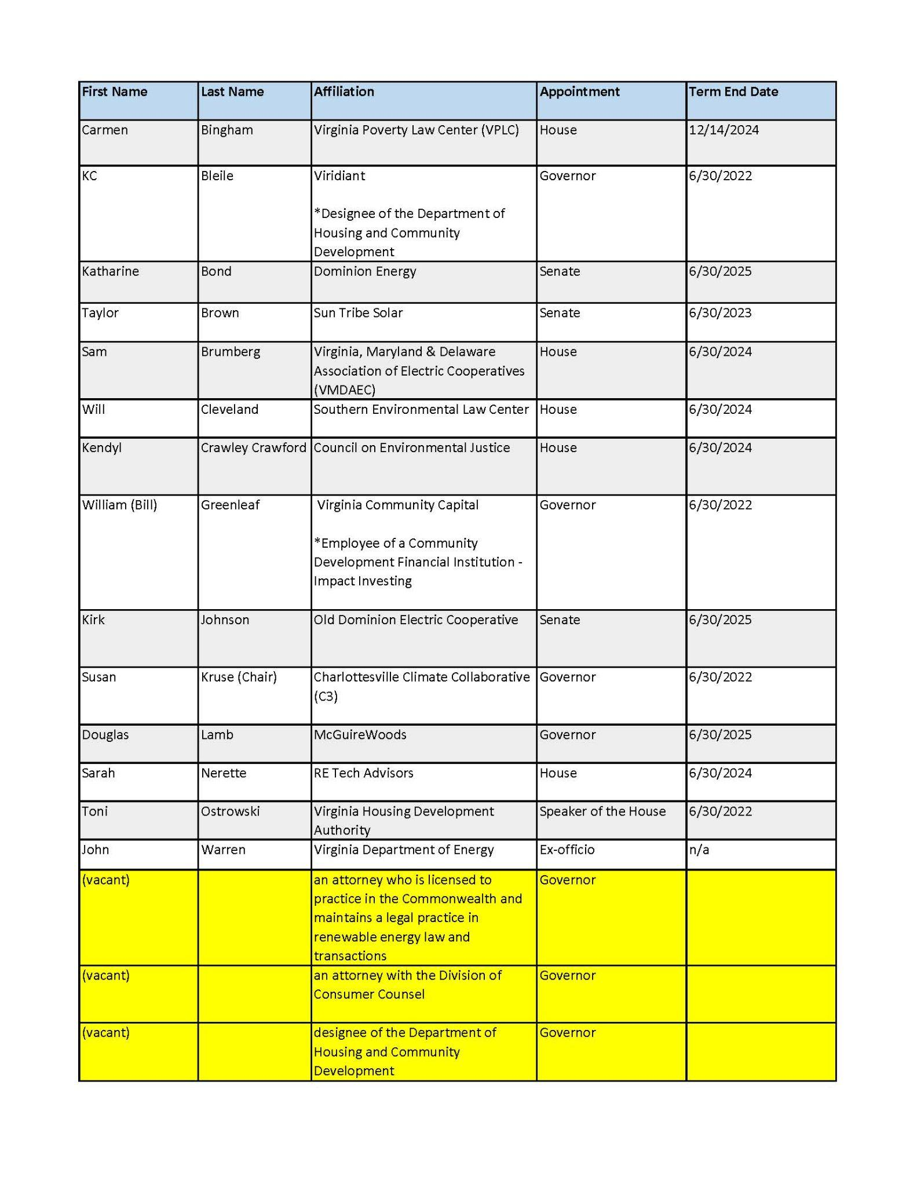

Appendix D: U.S. DOE LEAD Analysis by Virginia Census Tract (Top 50 by Average Energy Burden)
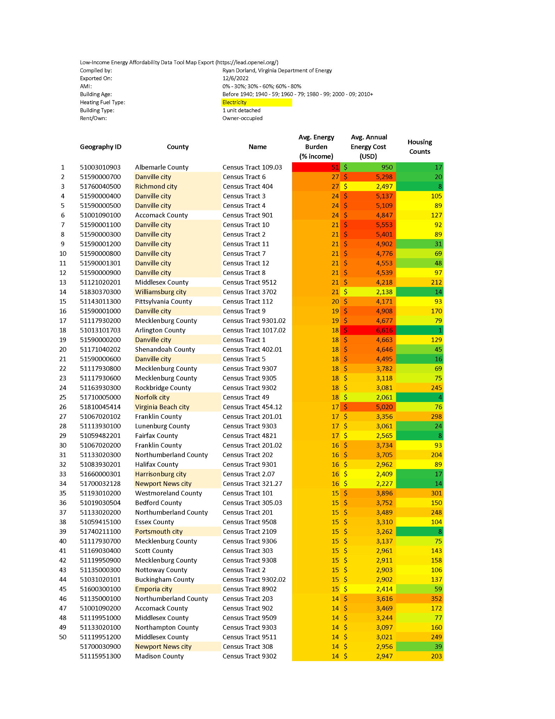

Full analysis available via US Department of Energy, Low-income Energy Affordability Data (“LEAD”) Tool

Appendix E: Virginia Electric Service Territories, courtesy of the Commission

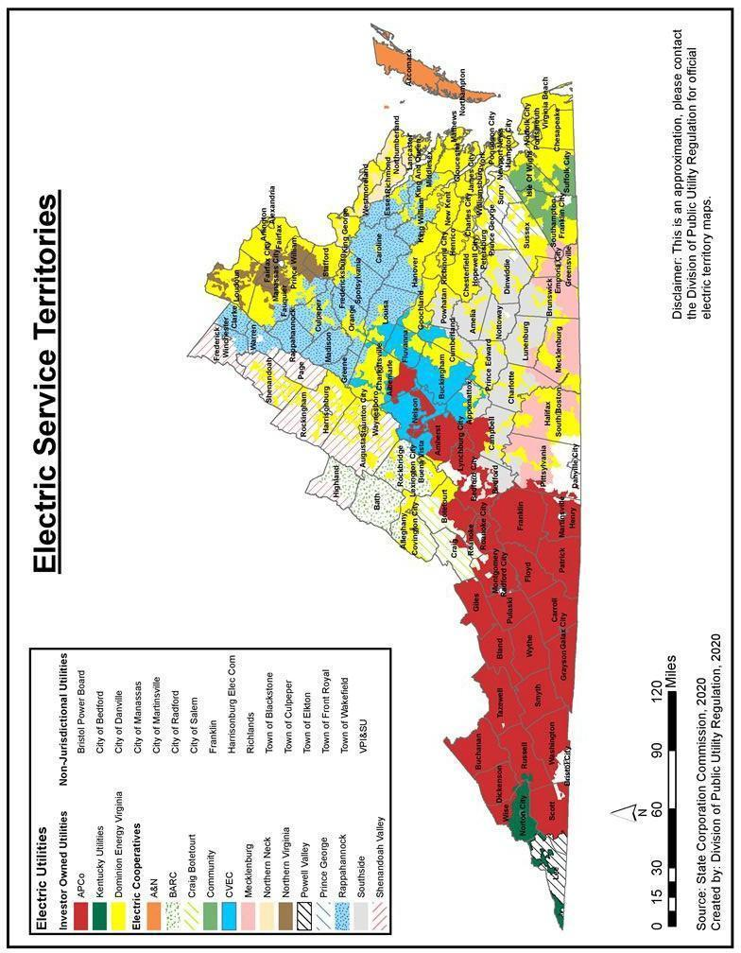

Appendix F: LMI Solar Stakeholder Map

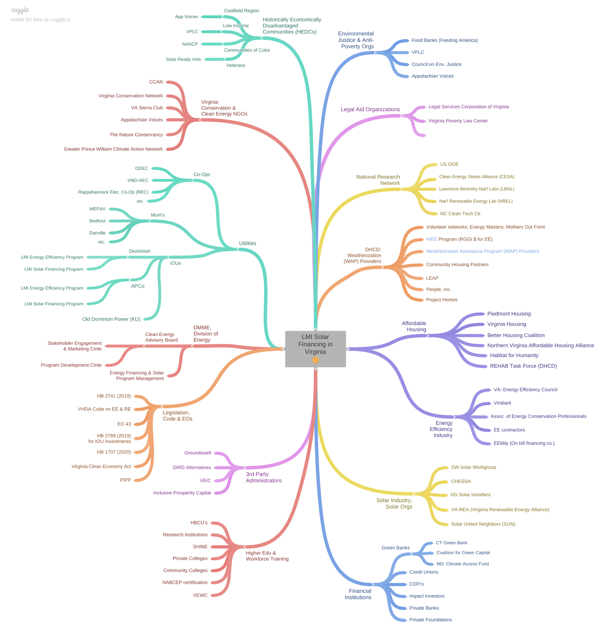

A high resolution version of this stakeholder map can be found online here via Coggle.it

Appendix G: Virginia Department of Energy Response to EPA Request for Information on Greenhouse Gas Reduction Fund

December 5, 2022
Virginia Department of Energy Responses for Greenhouse Gas Reduction Fund from the Inflation Reduction Act of 2022, Section 60103 (Zero Emission Technologies Program).
Respondent Name: Virginia Department of Energy
Point of Contact: Austin Counts, Rural and Industrial Clean Energy Program Manager
Address: 3405 Mountain Empire Rd, Big Stone Gap, VA 24219
Phone number: 276.870.6476
E-mail: austin.counts@energy.virginia.gov

Dear Administrator Regan and Senior Advisor Podesta:
Virginia Department of Energy (“Virginia Energy”) appreciates the opportunity to submit comments in response to the Request for Information regarding the Greenhouse Gas Reduction Fund (“GHG RF”) from the Inflation Reduction Act of 2022. We strongly believe this program is aligned with the goals of the 2022 Virginia Energy Plan in providing all Virginia residents with reliability, affordability, innovation, competition, and environmental stewardship in their energy needs. The comments in this response only pertain to Section 134(a)(1), the Zero Emissions Technology Program portion of the act targeted at Low-Income (“LI”) and Disadvantaged Communities (“DACs”).
Section 1: Low-Income and Disadvantaged Communities
1.1. Recommend that EPA allow eligible recipients to use state-established definitions of Low-Income and Disadvantaged Communities.
Several widely adopted tools exist to identify low-income and disadvantaged communities, including the U.S. Department of Energy’s Low-Income Energy Affordability Data (LEAD) Tool and the Climate and Economic Justice Screening Tool.[1] In addition, many states have their own definitions of low-income or disadvantaged communities that guide state programs aimed at benefiting such communities. One such example is Virginia’s definition of a Historically Economically Disadvantaged Community (“HEDC”). The VA Clean Economy Act of 2020 defines HEDC as “(i) a community in which a majority of the population are people of color or (ii) a low-income geographic area.”[2]
1.2. Recommend that any federal definition of low-income should include all households at or below 80 percent of the state median income or area median income, whichever is greater.
In the definition of HEDC, "low-income geographic area" means “any locality, or community within a locality, that has a median household income that is not greater than 80 percent of the local median household income, or any area in the Commonwealth designated as a qualified opportunity zone by the U.S. Secretary of the Treasury via his delegation of authority to the Internal Revenue Service.” The Virginia Clean Energy Advisory Board (“CEAB”), which was established to create a pilot program for disbursing loans or rebates for the installation of solar energy infrastructure in low-income and moderate-income households, uses a slightly different definition. The CEAB’s governing statute defines low-to-moderate income households as “those at or below 80 percent of the state median income or regional median income, whichever is greater.”[3]
The inclusion of households with less than 80 percent of the greater of state or regional median income means that households that have higher, moderate income but are still relatively low-income given the area’s income, and thus cost of living, are not left out. We recommend the EPA account for regional differences in median income when developing any definition of low-income.
1.3. Recommend that EPA encourages the use of the $20 billion component of the GHG RF in ways that reach moderate-income households. EPA should facilitate complementary coordination between GHG RF monies and other federal funds by aligning definitions of low- and moderate-income to the greatest possible extent.
States are presented with the challenge of developing effective, streamlined programs with numerous sources of federal and state funds. EPA, along with partners at the U.S. Department of Energy (“US DOE”), can assist states in meeting this challenge by ensuring, to the greatest extent possible, that definitions of “low-income” and “moderate-income” are standard across new programs. For example, EPA should coordinate with US DOE staff designing the residential energy efficiency and electrification rebate programs in establishing a definition for “moderate-income”. Again, federal agencies should also allow for flexibility in using state-established definitions for moderate-income where they exist.
The $20 billion component of the GHG RF should identify reaching moderate-income households as a key objective. With low-income households being served by the $7 billion component and higher-income households having increasing access to specialized clean energy financing options, it will be important to direct funds toward moderate-income households that may be left out by these other efforts.
Section 2: Program Design
2.1. Recommend that EPA allow flexibility in project and program design by the state to reach the greatest number of LI households and disadvantaged communities.
EPA should allow for a variety of funding mechanisms within the state plans including, but not limited to: grants, loans, third-party ownership models such as leases or power purchase agreements, and revolving funds such as a loan loss reserve. Assisting disadvantaged households with up-front costs associated with distributed energy projects would have outsized impacts in meeting Justice40 goals and ensuring benefits reach underserved communities which experience dual challenges of lagging economic growth and outsized impacts from climate change.[4]
2.2. Recommend that EPA offer guidance on consumer protections to mitigate potential risks of financing clean energy.
We recommend consumer protection requirements be incorporated as part of programmatic guidelines. This includes physical safety, such as design standards and buildings codes, and financial safety, such as preventing predatory or deceptive sales tactics. Consumer education materials should be provided throughout programs to aid in consumer protection. Grievance procedures should also be available for participants. Importantly, EPA and partner agencies or partners should assist eligible recipients in developing strategies for meeting those requirements, as this is an important and evolving area of work within the energy sector.
2.3. Recommend that EPA prioritize programs that support best practices in workforce development, labor standards, job training and apprenticeships within LI and DACs.
Financial assistance should be provided for accelerating the deployment of successful apprenticeship and workforce development programs, while helping disadvantaged communities develop partnerships and a trained workforce to ensure effective replication and implementation of successful programs. Working with existing weatherization assistance providers would be an example to build on for these efforts.[5]
2.4. Recommend that prior to funding opportunity announcements, potential applicants should have access to technical assistance and advanced planning grants for application planning, enabling strategic stakeholder engagement.
Funds may cover resource and staff capacity for community and stakeholder engagement and feedback processes. Technical assistance/planning grant opportunities should take place prior to the announcement of competitive funding opportunities to reduce the barrier of entry for applicants lacking the capacity for independent planning efforts.
Technical assistance for projects may include research on state-level LI and DACs solar policy needs, guidance on how to incorporate residents of manufactured homes, recommendations on best practices for utilizing IRA tax credits for low-income residential homes, and assistance to businesses owned or led by members of low-income or disadvantaged communities in navigating IRA tax and GHG RF requirements. Technical and financial assistance could allow for community-based organizations to partner with state energy offices to provide outreach and education within low-income and disadvantaged communities.
Section 3: Eligible Projects
3.1. Recommend that EPA consider coordination with existing programs that provide energy efficiency upgrades; address deferred maintenance funding.
US DOE’s Weatherization Assistance Program (WAP) is an existing mechanism to support LI households and reduce energy burdens.[6] In Virginia, energy efficiency services, such as those covered through Weatherization providers, is a required activity for LMI households prior to receiving financial support for behind-the-meter solar energy systems. EPA should recognize the challenges to effectively deploying WAP funds due to issues such as deferred maintenance or safety issues that lead households to be ineligible for efficiency improvements. Residents should be able to utilize financing for roof repairs and replacements, updating electrical systems, and tackling other deferred maintenance issues that prevent energy efficiency measures and clean energy technology from being provided.
In instances where energy storage systems are critical to the health and well-being of household residents, clean energy generation plus battery storage should be included as eligible projects.
Section 4: Eligible Recipients
4.1. Recommend that state energy agencies be considered as primary recipients of the $7 billion made available in Section 134(a)(1) of the program through a combination of formula and competitive funds.
Disbursing a portion of the $7 billion through formula grants (following the initial formula-based planning grants) would speed up the disbursal of funds and provide equal access to states lacking existing LI solar programs. We recommend that EPA not use the existing State Energy Program formula, and instead develop a formula that aligns with the objectives of Section 134(a)(1). State allocation of funds should take existing state funding and resources into account when determining allocations. State agencies have experience developing and implementing wide-reaching energy programs, coordinating with state and local partners and managing reporting and financial processes with federal agencies. States with fewer existing resources should be allocated additional funding relative to population size. A percentage of formula-based funding should comprise of a portion allocated to administrative costs and capacity. Require funds to be drawn down by funded entities to ensure compliance with program guidelines or be reimbursed to the EPA to support other LI and DAC zero emission programs regionally or nationally. Subrecipients of program funds should include agencies or organizations as identified by the states.
4.2. Recommend that EPA support programs designed to include a collaboration of partners with established connections to LI and DACs .
These partners could include local governments, community-based organizations, workforce boards, labor unions, higher-education institutions including community colleges, community development financial institutions, utility providers and private businesses. Requiring partnerships between a diverse array of stakeholders will strengthen a project’s effectiveness in the communities most in need. Subgrants for capacity building in DACs is sorely needed to develop materials, resources, training, and knowledge in community coalition building and project management capacity. A dedicated portion of funding could provide a catalyst for leadership development among communities and ensure buy-in with residents in marginalized LI and DACs. Technical and financial assistance could also be provided to these groups to help support federal or state reporting requirements.
4.3. Recommend that EPA provide explicit guidance regarding compensation or stipends provided to stakeholder groups and allowable costs that are not directly tied to subgrantee programs.
The EPA could also provide funding for technical assistance similar or in addition to the EPA’s Environmental Justice Thriving Communities Technical Assistance Centers or Technical Assistance Services for Communities Programs that would assist in community education and engagement concerning consumer protections, renewable energy knowledge, and general clean energy and energy efficiency resources.
Section 5: Oversight and Reporting
5.1. Recommend project metrics should include customer satisfaction measures, ensuring the LI customers and DAC are not receiving poorer quality service than market standard.
Estimated Return on Investments (RTO) or loan/lease/PPA conditions should be tracked, ensuring that customers were not subject to unfavorable market practices. In instances where energy storage capabilities are deemed eligible, the total kWh of battery backup installed should be reported. Projects including women-owned, minority-owned, small or micro, and locally owned businesses should be tracked to show impact on local economics.

Virginia Department of Energy appreciates your consideration of these recommendations as EPA creates this new Greenhouse Gas Reduction Fund, in part to benefit low-income and disadvantaged communities.

[1] https://screeningtool.geoplatform.gov/en/#3/33.47/-97.5
[2] https://lis.virginia.gov/cgi-bin/legp604.exe?201+ful+CHAP1193
[3] https://law.lis.virginia.gov/vacode/title45.2/chapter19/section45.2-1917/
[4] https://doi.org/10.1016/j.enpol.2022.112881 https://publications.wri.org/new-climate-economy-rural-america
[5] https://www.energy.gov/eere/wap/quality-work-plan-workforce-training
[6] https://www.energy.gov/eere/wap/weatherization-assistance-program

Appendix H: 2022 Virginia Department of Energy Summary Report from Solar Industry Interviews

Virginia Department of Energy

2022 Summary Report from Solar Industry Interviews

Analysis of Industry Perspectives on the Recently Issued Solicitation of a Solar Financing and Installation Partner for a Pilot Program for Low- and Moderate-Income Homeowners in Wise County, Virginia

December 12, 2022

Background

On June 21, 2022 the Virginia Department of Energy (Virginia Energy) released the Residential Solar Financing and Installation Partners for Low- and Moderate-Income Virginians request for proposals (RFP). This RFP sought proposals from solar installers and financiers (service providers) interested in providing solar installation services for low- and moderate-income (LMI) households in Wise County and the City of Norton. Participating households would be limited to owner-occupied, single-family residences. Eligible proposals would include a recommended financing model(s), income verification plan, installation performance and warranty package, solar equipment, customer outreach plan and small business subcontracting plan. Financial models were not limited in the RFP, but required that proposed models result in cash-flow positive transactions for customers. The full RFP can be found on eVA, Virginia’s procurement website.

Wise County and the City of Norton were selected by Virginia Energy as the target locality for the RFP in consideration of the Clean Energy Advisory Board’s (CEAB) 2021 report. This report identified Wise County in the top five locations for potential LMI solar marketing campaigns due to the large presence of low-income single-family owner-occupied households. Additional localities identified included Augusta County, the City of Waynesboro, Shenandoah County and the City of Franklin. Wise County was later selected to maximize program funds, reduce the geographic burden and concentrate program analysis. Additional considerations included the number of weatherized and waitlisted households through the Weatherization Assistance Program, proximity to Virginia Energy’s Big Stone Gap office and the county’s SolSmart Gold designation which indicates low-barriers to local permitting and inspections with rapid response times committed by the local jurisdiction.

On August 2, 2022 the RFP application period closed without a responding proposal. This initiated the development of a post-RFP assessment with the goal of understanding perceived or real program barriers as identified by solar installation and financing organizations. The goal is to then consider re-issuing a revised program RFP seeking solar partner(s) to ensure access to behind-the-meter solar energy for low to moderate income homeowners.

Goals and Methodologies

The post-RFP assessment identified three goals:

1) Collect information on increasing the competitiveness of the RFP;

2) Document program concerns and suggestions from stakeholders; and

3) Re-structure and publish a revised version of the LMI solar program.

Information and stakeholder input was collected through coordinated conversations and interviews with representatives of the solar industry. Each interview was conducted by Virginia Energy staff with participation from at least one CEAB member. Conducted interviews consisted of solar service providers that work in the LMI solar field and organizations working as LMI-serving nonprofits, solar trade associations or solar subject experts.

Companies and organizations interviewed included:

PosiGen,

Secure Futures,

Solar Holler,

Sunnova,

Tiger Solar,

Inclusive Prosperity Capital,

Sunrun,

Sigora Solar,

Arcadia,

Solar Energy Industries Association,

People Incorporated and

Solar United Neighbors.

Input provided by Solar Energy Industries Association, People Incorporated and Solar United Neighbors was collected through joint discussions.

Each service provider organization was asked to respond to a set of questions, held consistent throughout each interview. Questions included:

Was your organization aware of the RFP which the Virginia Department of Energy recently announced?

Did your organization consider submitting a proposal to the LMI Solar RFP in Wise County?

If you considered and declined the opportunity to submit a response, what was the primary factor in not submitting a proposal?

Were geographic barriers, such as the lack of regional installers or proximity to organizational headquarters, a deterrent for the RFP?

Was market size or customer acquisition a concern for the region expressed in the RFP? If so, what would alleviate that concern?

Would you consider the incumbent utilities and/or the policies which govern these utilities a barrier or deterrent for this Wise County LMI solar program? If so, what power providers would you consider to be more receptive?

Would a different approach be more attractive, perhaps a standing funding opportunity announcement sponsored by Virginia Energy?

Were there real or perceived barriers to utilizing special funds through the American Recovery and Reinvestment Act, with the provisions as listed in the RFP?

What is your perception of the policy environment in Virginia for solar leasing and/or PPAs? Do you perceive there to be a lack of clarity on solar leasing in Virginia? If this were to be clarified would that change your interest in this RFP or a similar program?

Do you consider the weatherization prerequisite as a barrier to the LMI solar program?

Would you consider potential administrative costs for reporting requirements as a deterrent for this program?

Would you consider the timing of the program length or future uncertainty of funding as a barrier for participation in the RFP?

Are there any other considerations, concerns or barriers regarding the RFP or LMI solar programs that you would like to express?

Barriers/Challenges identified by Stakeholders

Location and local installer accessibility

Location of the proposed program was identified as a significant consideration by multiple stakeholders. By limiting projects to Wise County and the City of Norton, solar service providers perceived challenges such as distance from existing or established facilities, limited or non-existent solar installation partnerships and concerns with market expansion. Distance from facilities was identified as a challenge by organizations that perform procurement, installation and financing services in-house. Location also presents challenges with viability of travel to service sites during and after installation. Organizations relying on contracted installers maintained fewer partnerships within distance of Wise County. Without nearby installation companies, it is more costly and difficult for financers to service the area. Furthermore, resistance to expansion into new service territories was primarily associated with the lack of additional incentives available to customers. Interviewees displayed interest in expansion efforts into Southwest Virginia but none were in a position to operationalize within the period identified in the RFP. Other locations within Virginia would likely be less of a barrier.

Leasing/PPA Regulation

Clarity as to whether residential leases are legal in Virginia was flagged as a key concern for some solar companies. Leasing and Power Purchase Agreements are two common 3rd party solar ownership models for LMI households. Most of the solar companies who are interested in owning 3rd party residential solar assets in Virginia prefer to use a lease instead of a Power Purchase Agreements (PPA). PPAs allow customers to pay solar companies for only the generated electricity in a given month. This preference is likely driven by two main reasons: (i) lease invoicing is simpler (the lease payment schedule is fixed at the time of lease execution), and (ii) electricity generation risk is shifted to the consumer when using a lease rather than a PPA. Leases are sometimes preferred by customers as well, because the monthly bill is a set cost that can be easily budgeted, whereas the monthly bill for a PPA will fluctuate based on energy production.

Pursuant to § 56-594.02 Section 3. of the Code of Virginia, 3rd party PPAs are permissible for low-income utility customers who receive electricity from Dominion Energy Virginia (Dominion), Appalachian Power Company (APCo) or Old Dominion Power (ODP)/Kentucky Utilities (KU):

A solar-powered or wind-powered generation facility with a capacity of no less than 50 kilowatts and no more than three megawatts shall be eligible for a third party power purchase agreement under a pilot program; however, if the customer under such agreement is a low-income utility customer, as defined in § 56-576, or is an entity with tax-exempt status in accordance with § 501(c) of the Internal Revenue Code of 1954, as amended, then such facility is eligible for the pilot program even if it does not meet the 50 kilowatts minimum size requirement.

"Low-income utility customer" means any person or household whose income is no more than 80 percent of the median income of the locality in which the customer resides. The median income of the locality is determined by the U.S. Department of Housing and Urban Development.

According to the State Corporation Commission, three Virginia utility companies have pilot programs: Appalachian Power Company, Dominion Energy Virginia and Kentucky Utilities/Old Dominion Power.

Furthermore, by law, nonprofit or governmental member-consumers of Virginia electric cooperatives are able to utilize third-party PPAs for net metered solar. Several cooperatives have additionally approved the use of third-party PPAs for other types of member-consumers, pursuant to law. Additional information from the cooperatives on this issue is available at nem.vmdaec.com.

Long term financial incentives

Some of the stakeholders who exclusively own and operate 3rd party residential solar facilities made it clear that the size of the incentive offered through the RFP alone was not sizable enough to warrant an expansion into Virginia. Many indicated that they would need to see an accessible local market with stronger incentives for residential solar. Strong financial incentives can take a variety of shapes, such as state tax credits, state tax exemptions, multi-year state grant programs, a well defined state REC market, as well as incentives which apply to all income levels, such as programs with a tiered structure that offer something for everyone up to a certain income level. However, a program funded by a one-time grant for a two-year period doesn’t provide long term market certainty to attract new investments in new markets. One firm indicated needing at least three years of certainty before expanding into a new market. With the recent passing of the Inflation Reduction Act (“IRA”), the additional 10% Federal Investment Tax Credit (“ITC”) for low-income projects will certainly provide a positive boost to the revenue side of solar installer models.

Understanding of Virginia Renewable Energy Certificate (REC) market

Pursuant to § 56-585.5. of the Code of Virginia, Dominion must meet 1% of its annual Renewable Portfolio Standard (RPS) with solar, wind, or anaerobic digestion resources with a capacity of one megawatt or less located within Virginia, and to the extent that low-income qualifying projects are available, then no less than 25% of this 1% shall be composed of low-income qualifying projects. Deficiency payment for any shortfall shall be $75/MWh in 2021, increasing at 1% per annum thereafter. Dominion may purchase RECs as needed to fulfill compliance.

Most stakeholders were unaware that low-income qualifying RECs had a special carveout within the ‘1% carveout’. Stakeholders were also unaware of the process for engaging in the Virginia REC market. Stakeholders view established REC programs with clear annual targets as a reliable source of revenue. At ~50% of the host utility bill savings on a $/kWh basis, RECs should provide a significant source of revenue. A 6kWdc residential rooftop system located in Virginia would generate around 7 RECs per year. Based on clearing prices from the three largest aggregators operating in Virginia, in 2022 those 7 RECs would be worth approximately $360, with RECs trading on average $51.43/REC., ,

Income verification

The income verification process was identified as an administration consideration to the solar installation and financing organizations interviewed. Organizations referenced income verification as an administrative burden (though not necessarily something they couldn’t overcome with the right incentive structure). They also described community considerations relating to only reaching a subset of the market based on household income eligibility, while not having incentives to offer to others that fall outside the income threshold. FICO credit score was also identified as a way to identify qualifying households without utilizing strict income-based requirements. Preference was shown for programs that service “Low-income Communities '', that being a defined area in which anyone who met non-income-based criteria, such as prior participation in energy efficiency programs, would qualify for installation.

Recommendations for Future Program Development

Virginia Energy considers the top barriers for participation in the recent RFP were: (1) third-party financing options via solar leases, (2) location restrictions, (3) limited understanding of the Virginia REC market, (4) income qualification and verification model, (5) a lack of sustained financial incentives.

Virginia Energy and related partners should consider the following revisions for LMI solar program design.

1) Policy and/or regulatory clarification on solar leases as well as additional information on power purchase agreements (PPAs). As solar leases are widely used and beneficial for LMI households, clarifying the legality of such agreements may greatly increase the affordability of residential solar for all households in the commonwealth. As requested by the CEAB in June of 2022, the Office of the Attorney General is considering an official opinion on the legality of residential solar leases in Virginia. Should this official opinion be provided, such determination shall be included in a future RFP.

Information on utilities permitting residential PPAs with low-income customers shall be provided to increase the understanding and utilization of existing third-party financing models in the Commonwealth. This shall be especially impactful should an official opinion on lease legality be determined inconclusive or unlawful. The Commonwealth may consider expansion of access to residential PPAs beyond low-income households to incent multiple businesses to expand into Virginia, creating new jobs and access to affordable, behind the meter clean energy solutions.

2) Expansion to geographic areas as identified by project partners. To address concerns with location and installer accessibility, Virginia Energy may expand the scope of the program to include communities throughout the Commonwealth. By allowing service providers to select the best localities for their financial model, the program would increase the likelihood of a robust response to a future RFP while ensuring program participant benefits are maximized. Service providers may be allowed to identify specific areas for eligibility or propose to service any energy customer within the state.

3) Include information on Virginia REC markets. The RFP should identify the available financial tools to utilize the REC market and increase financial viability of LMI solar for service providers. This shall include the process of buying and selling RECS in Virginia, the expected production of RECs per household and information on the low-income REC carveout.

4) Clarification of income eligibility and verification. By clarifying the income verification model and income levels, Virginia Energy would increase the understanding of programmatic prerequisites, provide a clearer path for income verification and increase the perceived market potential for service providers. Income limits based on household size shall be identified and displayed within program eligibility rules to show the range of incomes allowable for various household sizes.

Virginia Energy shall also consider taking on the administrative burden or alternative methods of verifying low-income customer qualifications. Considerations may include census tract based pre-qualification, existing participation in income-based programs and self-attestation. Methods should be selected that fit reporting requirements for the program while reducing customer and service provider burdens and risks.

Next Steps

Virginia Energy will proceed with program design with strategic consultations from the Clean Energy Advisory Board, Clean Energy States Alliance, and other parties as identified.

New federal funding opportunities will be strongly considered based on new federal guidance and application considerations. Should federal and/or state funding opportunities be realized, a revised RFP will be utilized for the program as needed. Should additional funding not be secured for a Virginia LMI solar program, a revised RFP shall move forward with existing funds.

The agency will continue to consult with the Office of Attorney General on legal considerations, as well as the executive branch and General Assembly on state-level policy considerations to create pathways for low-income homeowners to access clean energy options to help lower energy bills.

Appendix I: Letter to Office of Attorney General Opinions Section From Clean Energy Advisory Board

https://law.justia.com/codes/virginia/2020/title-45-2/chapter-19/
https://mvendor.cgieva.com/Vendor/public/ADVSODetails.jsp?PageTitle=SO%20Details&DOC_CD=RFP&Details_Page=ADVSODetails.jsp&DEPT_CD=A409&BID_INTRNL_NO=2916&BID_NO=2916&BID_VERS_NO=1
https://energy.virginia.gov/renewable-energy/documents/CEAB/Reports/CEAB_Annual_Report_2021_FINAL-TO-GA.pdf
https://scc.virginia.gov/pages/Renewable-Energy-Pilot-Program
https://law.lis.virginia.gov/vacode/title56/chapter23/section56-585.5/
https://www.suntribetrading.com/virginia-srec-pricing
https://help.srecs.solsystems.com/hc/en-us/articles/4544763082135-Virginia-SREC-Contract-Options
https://www.flettexchange.com/

