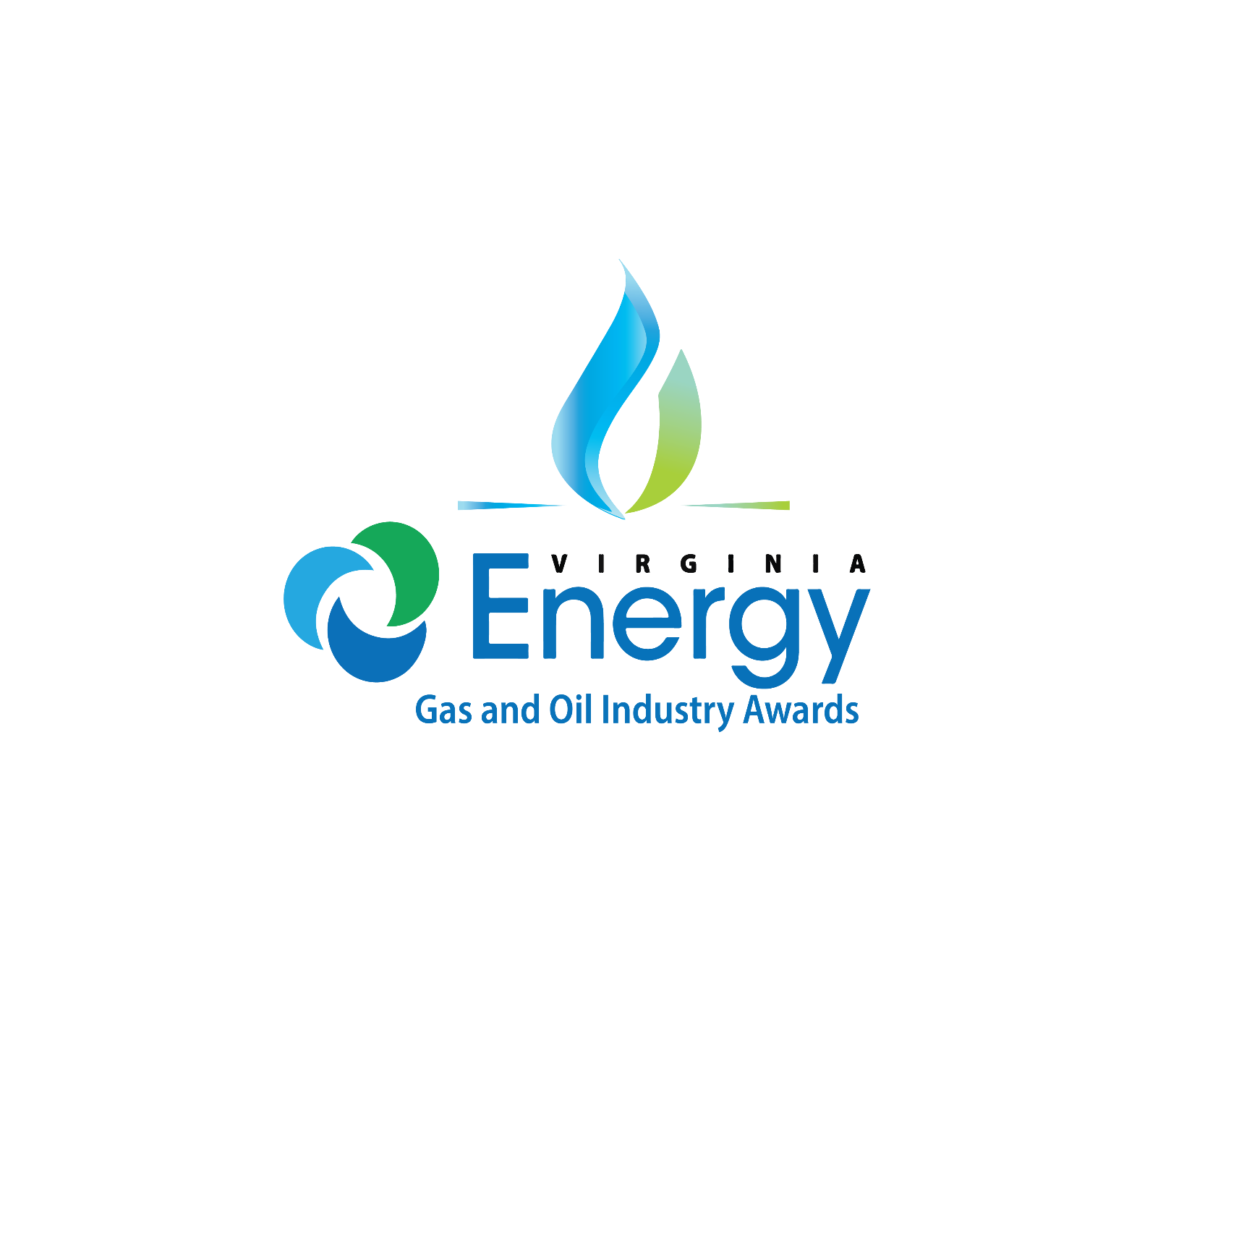

**General Information**

The Virginia Department of Energy’s Gas and Oil program, in partnership with the Virginia Oil and Gas Association (VOGA), created a program to recognize outstanding achievements by members of the gas and oil industry in Virginia. Nominations may be submitted by the nominee themselves or from other outside organizations**.** Entries must have been initiated or ongoing during the 2024 calendar year. Each individual entry must be on a separate form.

**How to Enter: Entries must be submitted to Virginia Energy by July 31, 2025**.Digital entries are preferred and may be sent to **sarah.gilmer@energy.virginia.gov**. Please submit one PDF to include nomination form and synopsis. Physical entries may be mailed or delivered to Virginia Department of Energy ATTN: Sarah Gilmer, 3405 Mountain Empire Road, Big Stone Gap, VA 24219.

**Judging:** The awards committee will include Virginia Energy gas and oil staff.

**Announcement of Winners:** The award winners will be announced at the **Fall Annual VOGA Meeting Banquet, located at the Boars Head Resort in Charlottesville, VA** **in October 2025**. Winners will be notified in advance so they can make appropriate arrangements to attend.

***Please complete with full and accurate contact information. This information will be used to notify winners and communicate details about award events.***

**Name of Nominee:**

**Address:**

**Phone: Email:**

**AWARD CATEGORIES *See page two for description of each award**

|  |  |
| --- | --- |
| **Environmental Stewardship**    **Community Outreach**  **Local Distribution Company of the Year**  **Operator of the Year** | **Outstanding Service Provider of the Year**  **Individual Excellence**  **Other** |

### Title of Entry: ___________________________________________________________________________

### Entry Synopsis: (Between 250-600 words attached on separate document) Tell our panel of judges why you should win this award. Please keep your response to no more than two pages. Feel free to include data that shows results and reference supporting documents you may wish to include. If possible, please provide supporting photos and videos for your awards entry to be used as marketing materials in the future. Categories will only be judged on the information provided in each nomination submission and their good standing with Virginia Energy.

**Supporting Documents: Please include any supporting documents as identified in synopsis. Type/Title of Supporting Information _________________________________________________________________**

**Entry Submitted by:**

**Phone: Email:**

**Judging Categories**

## **ENVIRONMENTAL STEWARDSHIP** This award is for companies that pride themselves on environmental stewardship. Applicants should describe how they demonstrated excellence in areas associated with the protection of the environment. This can include regulatory compliance during production, transmission and distribution of natural gas.

## **COMMUNITY OUTREACH** This award recognizes companies that make a positive impact in the communities where they do business and in which they serve. Applicants should share examples that made an impact on customers and others. Projects or programs should demonstrate excellence in community initiatives, education, public awareness or community outreach. The cumulative effort of employees and their involvement should also be described in the entry.

**LOCAL DISTRIBUTION COMPANY OF THE YEAR** This award is set forth to acknowledge a local distribution company (LDC) of natural gas in the Commonwealth of Virginia. The applicant should demonstrate excellence in safety, environmental conservation, regulatory compliance, community outreach, innovation and/or development.   The applicant should submit an entry describing all major aspects of the project(s) and/or program(s) and how the applicant met the criteria of this award.

## **OPERATOR OF THE YEAR** This award is set forth to acknowledge any operator within the production of natural gas in the Commonwealth of Virginia. The applicant should demonstrate excellence in safety, environmental conservation, regulatory compliance, community outreach, innovation and/or development. The applicant should submit an entry describing all major aspects of the project(s) and/or program(s) and how the applicant met the criteria of this award.

**OUTSTANDING SERVICE PROVIDER OF THE YEAR** This award is open to contracting companies that work in the natural gas industry. An award of prestige, this recognition is designed for those companies that have outstanding records in both safety and environmental stewardship. Nominations should include descriptions for both and include any commitment to community made by the contracting company.

## **INDIVIDUAL EXCELLENCE** This award recognizes an outstanding individual who has demonstrated exceptional dedication and performance across multiple areas, including leadership, safety, workmanship, education, outreach, and innovation. This award honors someone who consistently goes above and beyond in their role—whether as a current employee, a rising star, or through a lifetime of achievement. Their contributions have made a significant impact on their team, the organization, and the industry at large, setting a high standard for excellence and inspiring others to follow suit.

## **OTHER** This award category is set forth to acknowledge special effort(s) and/or program(s) of excellence in or relating to the natural gas industry of the Commonwealth of Virginia that do not fall within one of the other categories. These effort(s) and/or program(s) must produce exceptional results, above and beyond the scope of normal operations and responsible stewardship. All entries for this award are subject to re-categorization into another award’s criteria at the judging committee’s discretion. The applicant should submit an entry describing all major aspects of the project(s) and/or program(s) and how they were coordinated throughout the project’s duration.